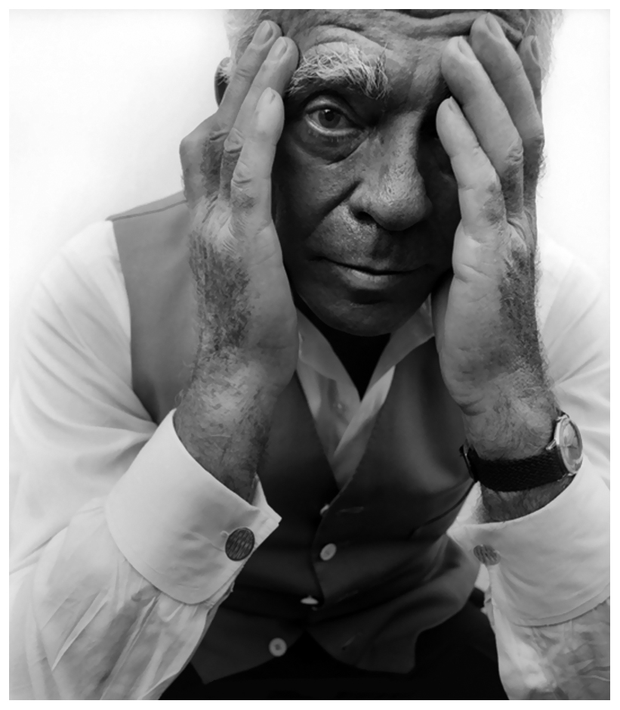
Horst P. Horst
Horst Paul Albert Bohrmann (August 14, 1906-November 18, 1999), known as Horst P. Horst was a German-American fashion photographer. A 60 year career in photography, Horst P. Horst is one of the world’s leading fashion and portrait photographers of the 21st Century, becoming one of the first photographers to perfect the new colours techniques of the 1930’s. His photography has featured on countless pages in vivid colour and appeared on over 90 covers of Vogue, Harpers and Queen and House of Garden from the 1930’s onwards.
In 1996, Horst received the Master of Photography award.
Horst is best known for his photographs of women and fashion. But is not fashion obsessive. He is also recognised for his photographs of interior architecture, still lifes, including plants, and environmental portraits. He said in 1984: “Fashion is an expression of the times. Elegance is something else again.” His photographs were seen to be different with the making of images of elegance, style and a complex glamour. His work frequently reflects his interest in surrealism and his affection of the ancient Greek ideal of physical beauty.
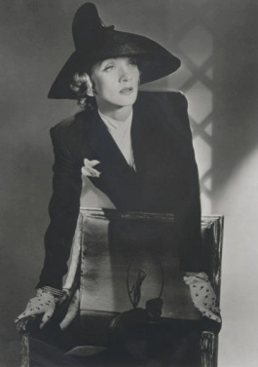
His method of work required careful preparation for the shoot, with lighting and studio props arranged in advance. His directions to models were brief and to the point. His published work uses lighting to pick out the subject; he repeatedly used four spotlights, often one of them pointing down from the ceiling.
His photos hardly ever included shadows falling on the background of the set. Horst rarely used filters in his work. Even though the majority of his work is in black and white, much of his coloured photography includes largely monochromatic settings to set off a colourful fashion. Horst’s colour photography did include documentation of society interior design. In general, Horst left it up to others to develop, print, crop, and edit his work. One of his most famous portraits is of Marlene Dietrich, a German-American actress and singer; taken in 1942, for Vogue. She objected the lighting that he had selected and arranged, but he used it anyway. Dietrich liked the effects and later used a photo from the session in her own publicity.
Before America had entered the war and Britain stood alone against Germany, there was a ‘Bundles for Britain’ campaign. This campaign consisted of different manufacturers would set aside and advertise some of their garments, and the proceeds from the sales would go to help the British war effort. This photograph of Marlene Dietrich was a part of this campaign, taken for Vogue.
Horst has said that “In the old days photography wasn’t considered one of the arts.” He felt like no one reflected it to be an art. He knew of many artists such as, Picasso, Matisse and Miró that didn’t think photography was that of an importance. Despite this, they were known to have admired the works of both French photographers, Eugène Atget and Henri Cartier-Bresson. Living in Paris became a huge inspiration to Horst, he felt like it was a real community of artists, with the likes of Jean Cocteau, Christian Bérard and many more. They were all so interested in each other’s work.

